Loan Dataset Report:

Introduction:

Dataset Overview:

Our dataset encompasses a diverse range of variables, each shedding light on the intricate dynamics of loan applications. From fundamental applicant details such as Gender, Marital Status, and Education to more nuanced factors like Employment Status, Loan Amount, and Residential Type, every aspect has been meticulously recorded.

Key Attributes:

1. Gender: A demographic identifier providing insights into the gender distribution among loan applicants.

2. Marital Status (Married, Not Married): Categorization based on marital status aiding in demographic segmentation.

3. Education (Graduate, Non-graduate): Classification based on educational background for further analysis.

4. Employment Status (Employed, Unemployed): Distinction between employed and unemployed applicants, crucial for risk assessment.

5. Loan Amount: The principal amount applied for, providing a measure of financial need and capacity.

6. Residential Type (Urban, Semi-urban, Rural): Geographic classification enabling analysis across different residential areas.

Questionnaire:

Q1. How many male graduates who are not married applied for Loan? What was the highest amount?

Q2. How many female graduates who are not married applied for Loan? What was the highest amount?

Q3. How many male non-graduates who are not married applied for Loan? What was the highest amount?

Q4. How many female graduates who are married applied for Loan? What was the highest amount?

Q5. How many male and female who are not married applied for Loan? Compare Urban, Semi-urban and rural on the basis of amount.

Analytics:

Q1. How many male graduates who are not married applied for Loan? What was the highest amount?

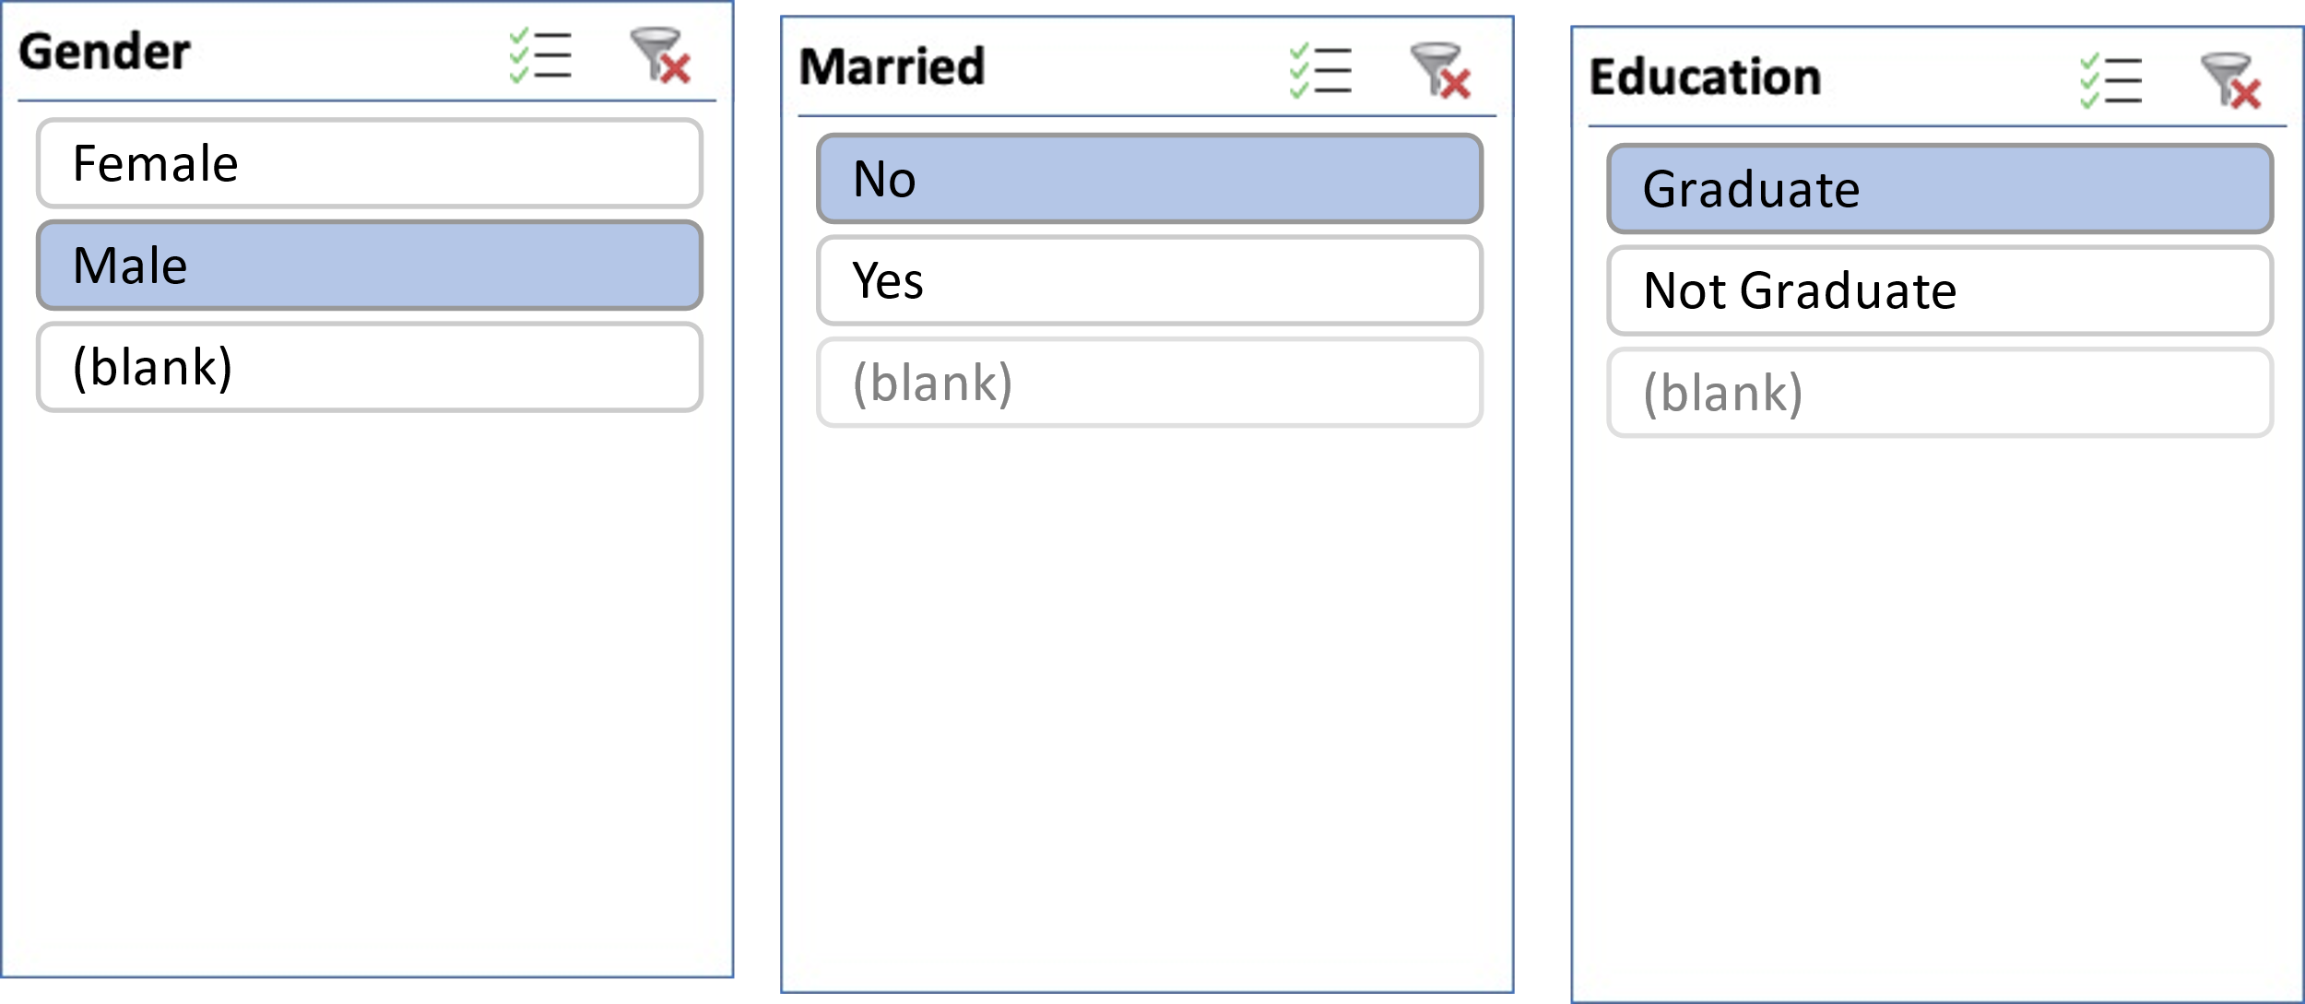

Q2. How many female graduates who are not married applied for Loan? What was the highest amount?

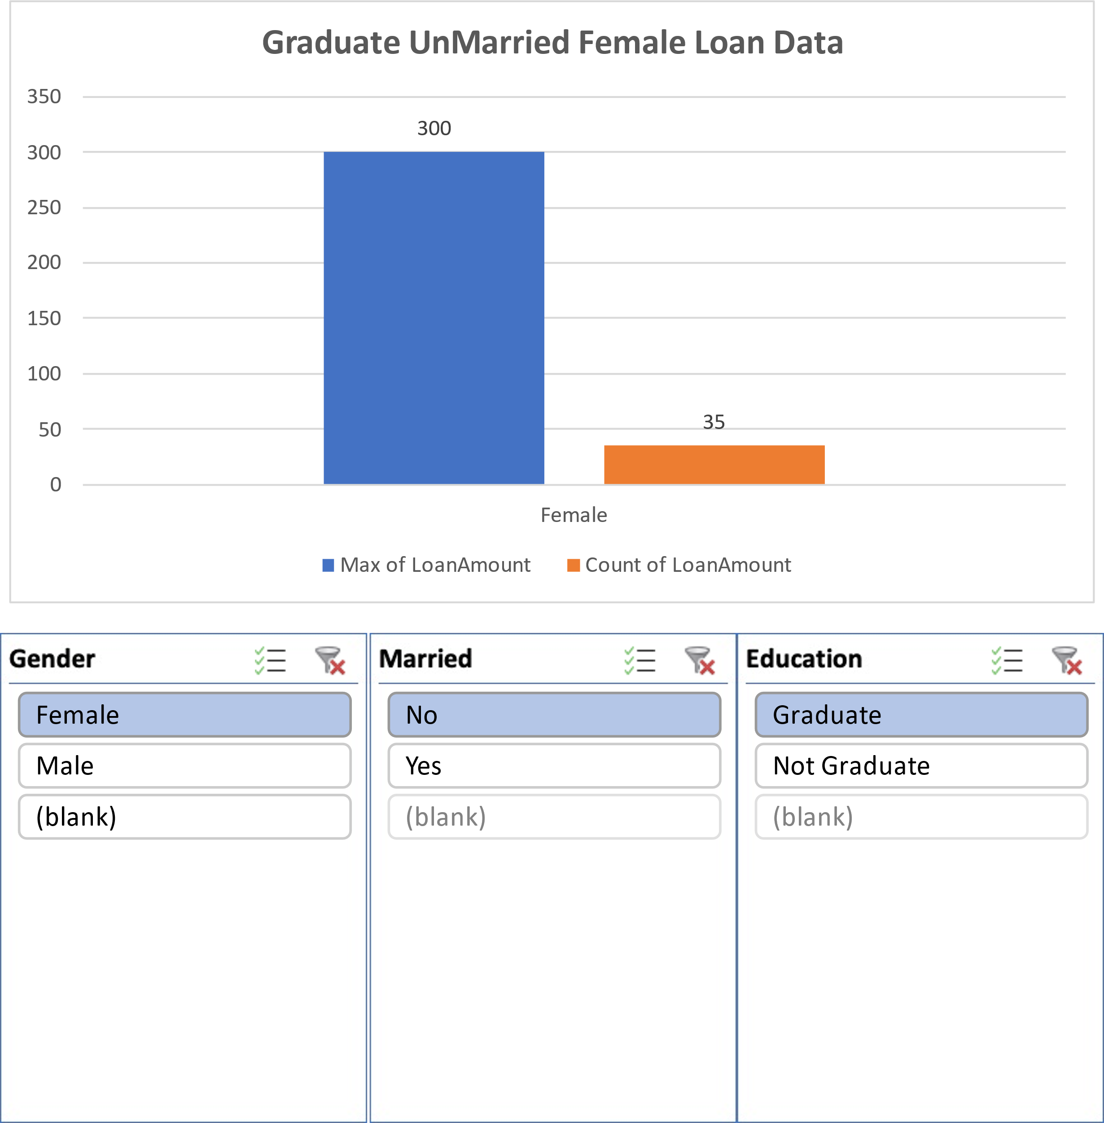

Q3. How many male non-graduates who are not married applied for Loan? What was the highest amount?

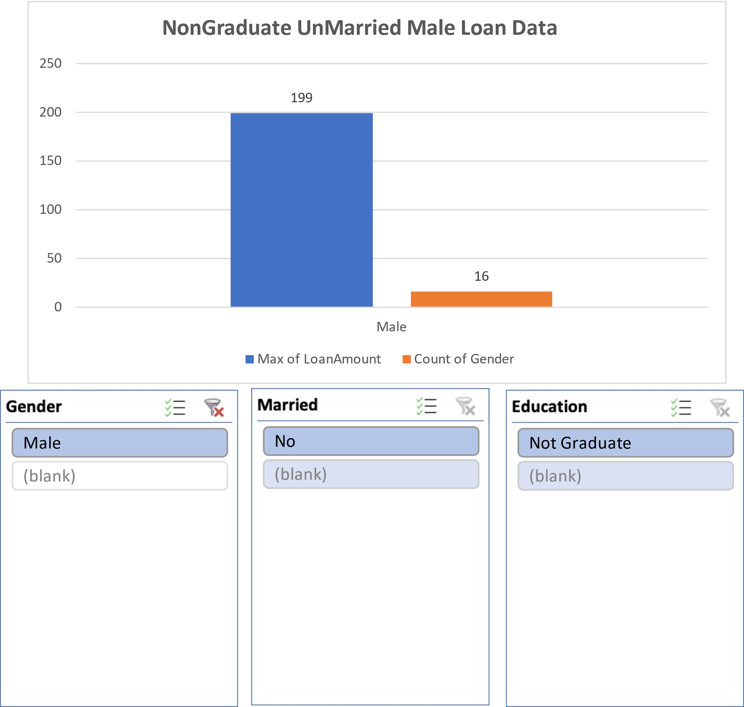

Q4. How many female graduates who are married applied for Loan? What was the highest amount?

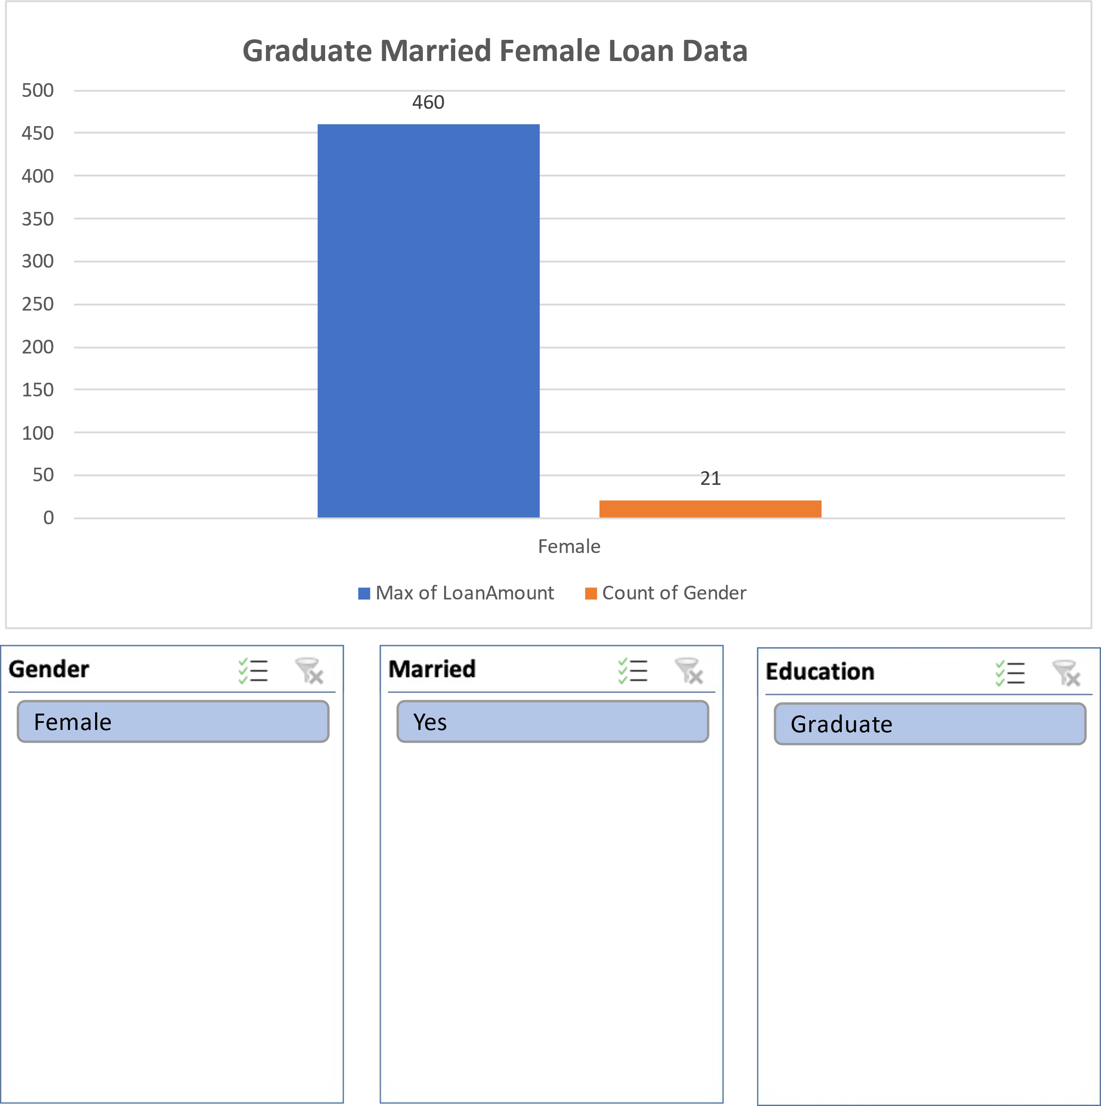

Q5. How many male and female who are not married applied for Loan? Compare Urban, Semi-urban and rular on the basis of amount.

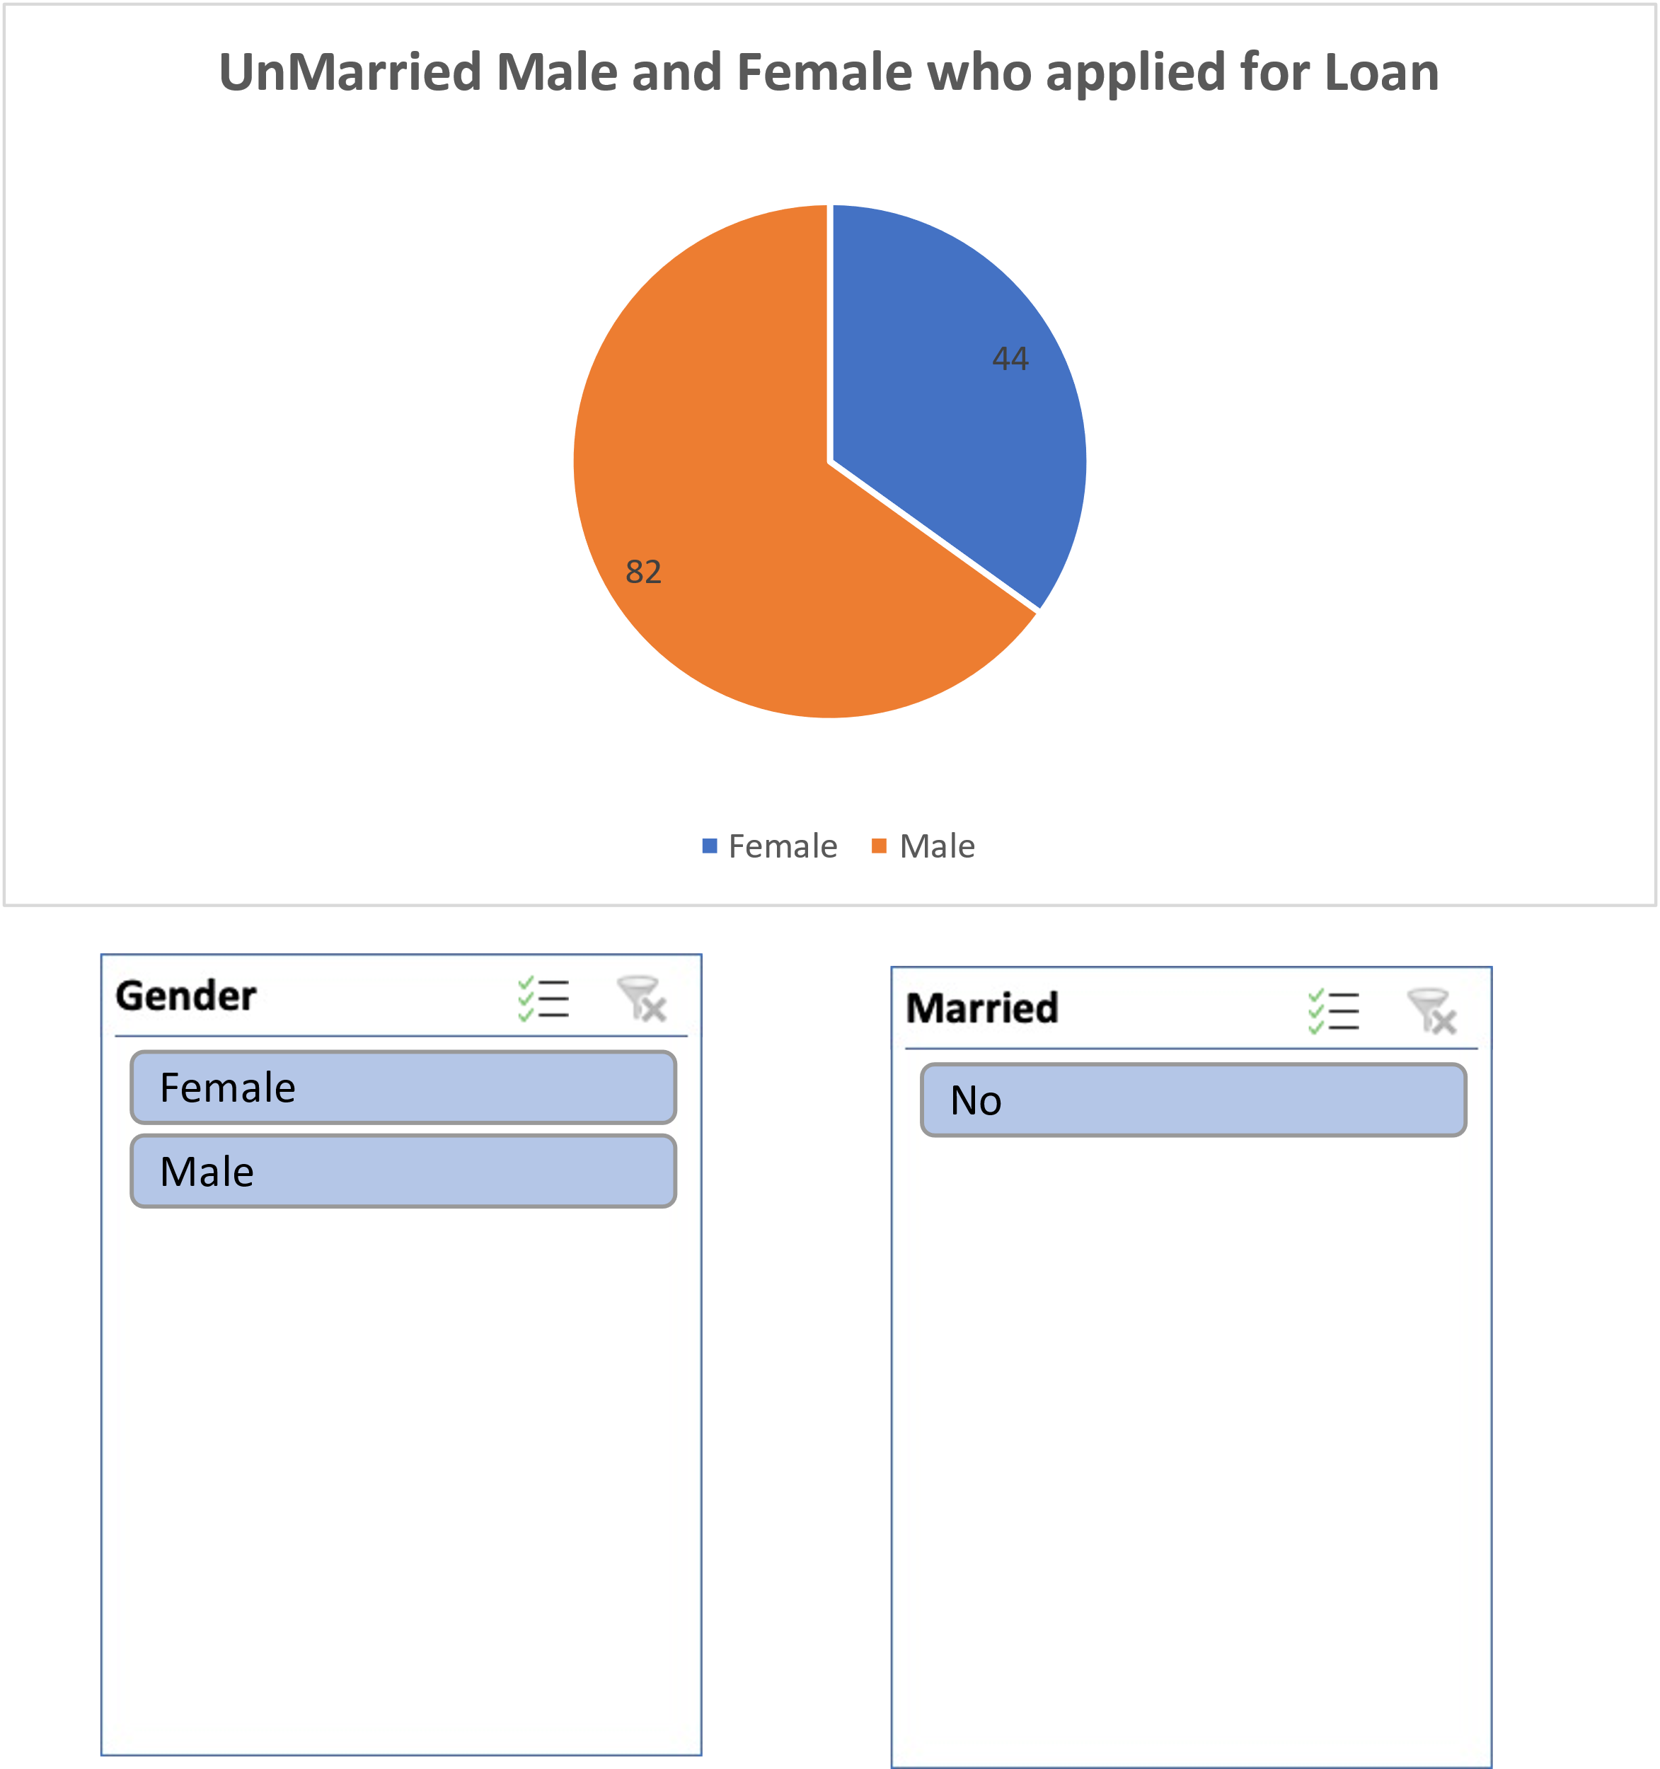

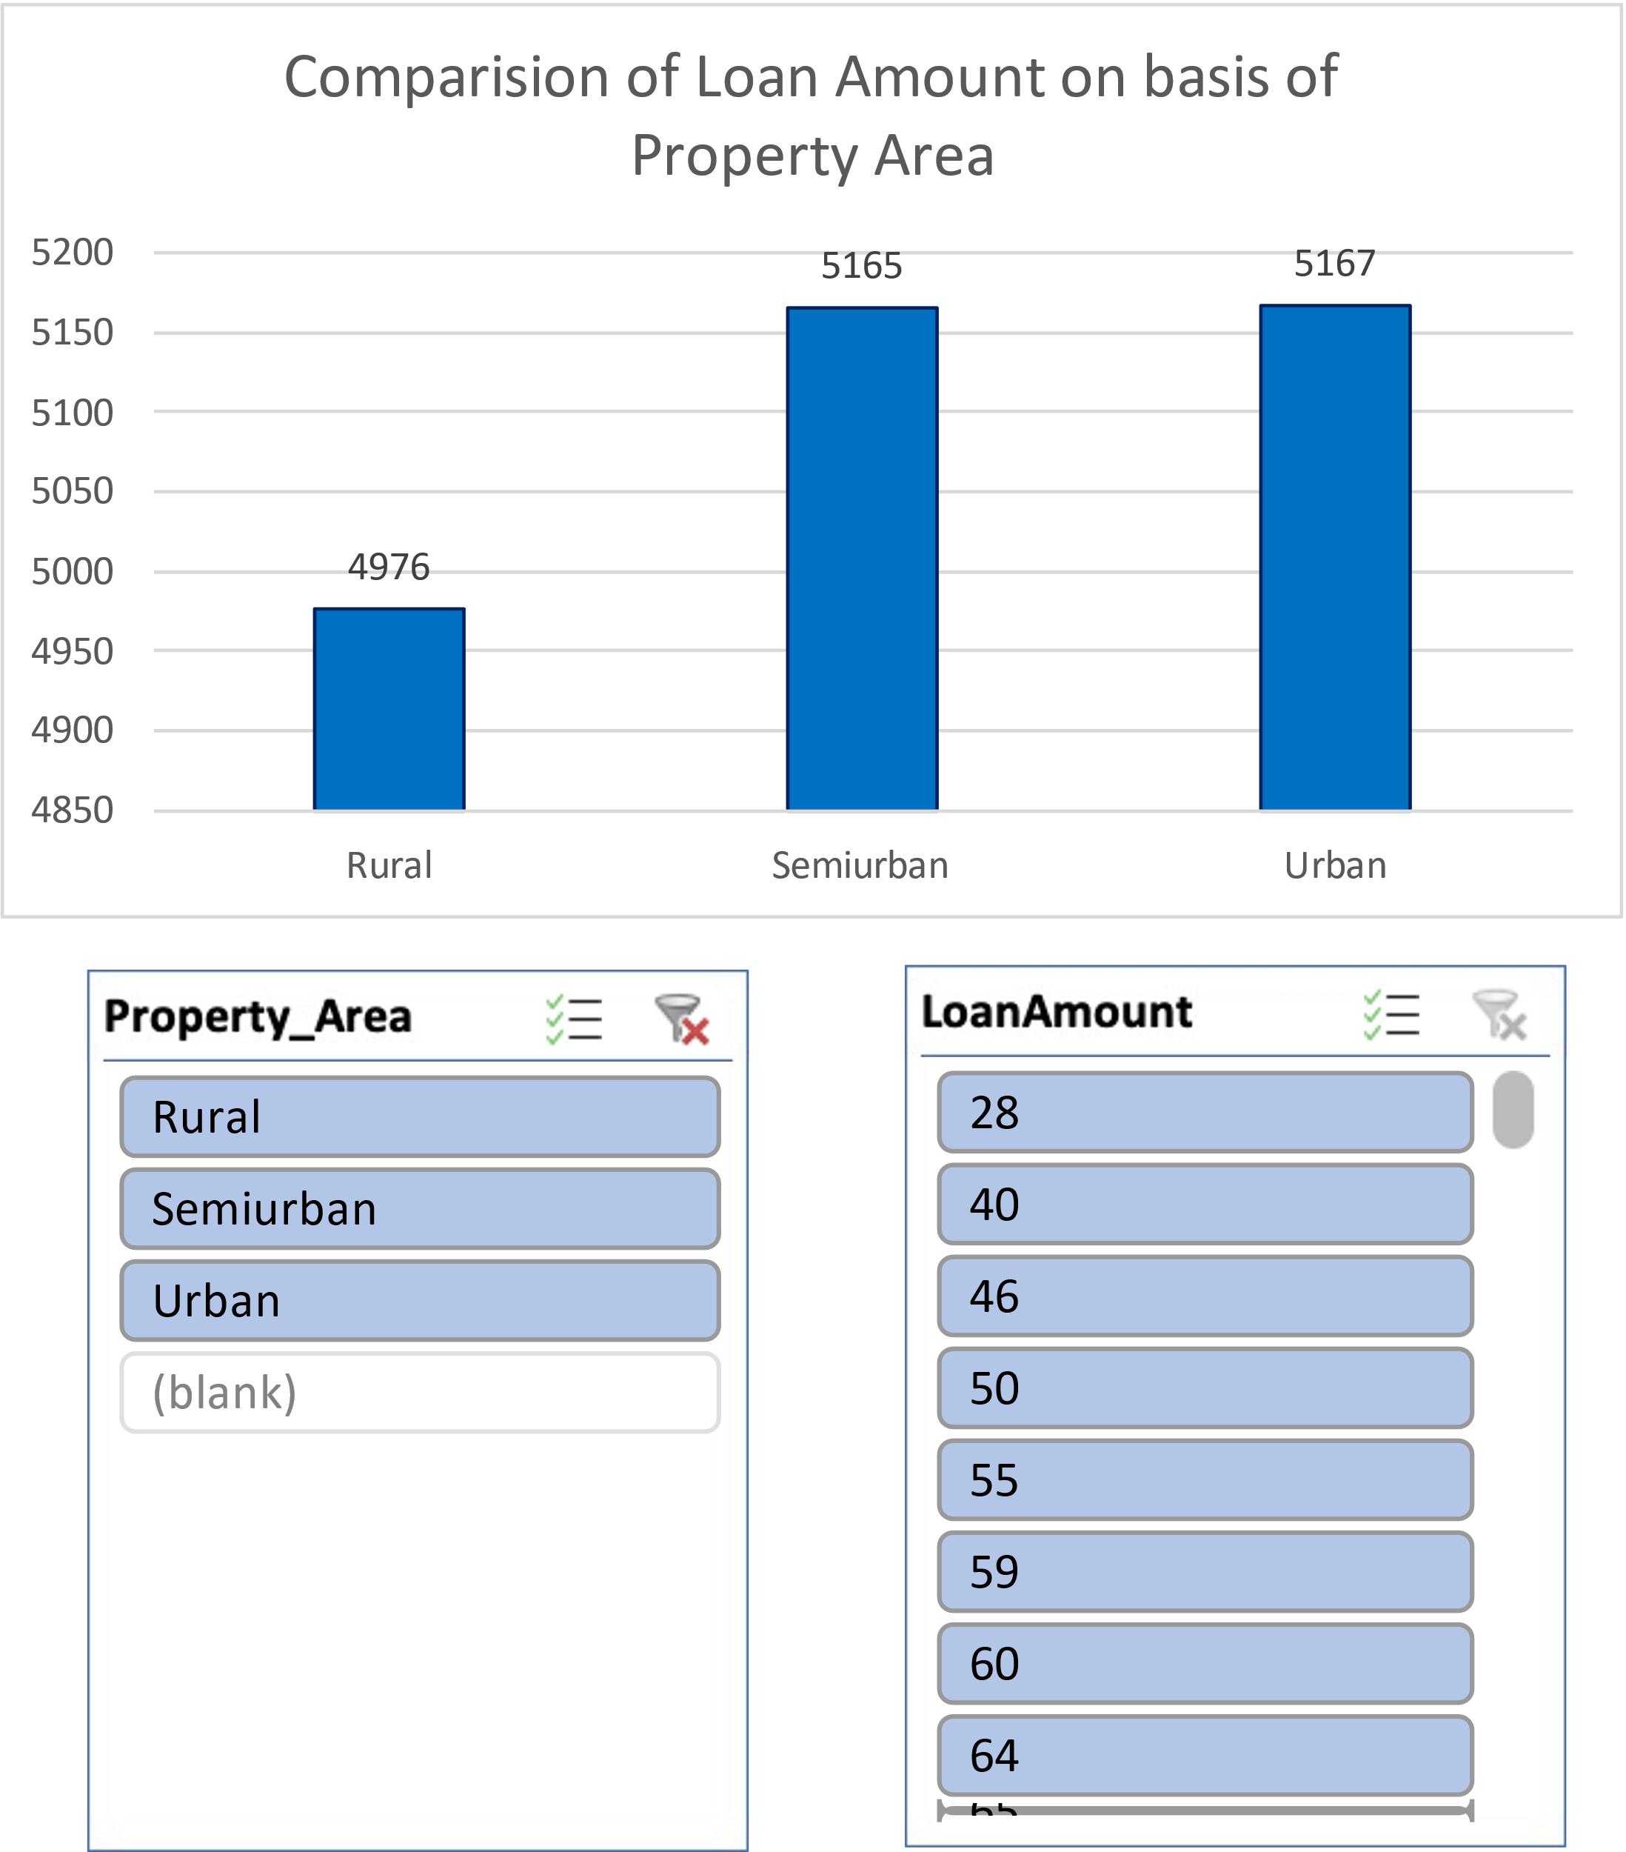

Conclusion:

Our analysis, using varied visualization techniques, revealed valuable insights, enhancing comprehension and decision-making. Visualizing data clarified complex findings, facilitating actionable strategies. This highlights the pivotal role of data visualization in extracting meaningful insights and informing decisions effectively.

Regression:

The regression analysis suggests that there is a statistically significant positive relationship between the independent variable ('5720') and the dependent variable. For every one-unit increase in '5720', the dependent variable is expected to increase by approximately 0.0059 units. However, it's important to note that the model only accounts for about 21.1% of the total variance in the dependent variable.

|  |  |  |  |  |  |  |  |  |
| --- | --- | --- | --- | --- | --- | --- | --- | --- |
| SUMMARY OUTPUT | |  |  |  |  |  |  |  |
|  |  |  |  |  |  |  |  |  |
| *Regression Statistics* | |  |  |  |  |  |  |  |
| Multiple R | 0.45908096 |  |  |  |  |  |  |  |
| R Square | 0.21075532 |  |  |  |  |  |  |  |
| Adjusted R Square | 0.20858707 |  |  |  |  |  |  |  |
| Standard Error | 56.0766111 |  |  |  |  |  |  |  |
| Observations | 366 |  |  |  |  |  |  |  |
|  |  |  |  |  |  |  |  |  |
| ANOVA |  |  |  |  |  |  |  |  |
|  | *df* | *SS* | *MS* | *F* | *Significance F* |  |  |  |
| Regression | 1 | 305655.205 | 305655.205 | 97.2004502 | 1.7676E-20 |  |  |  |
| Residual | 364 | 1144629.42 | 3144.58631 |  |  |  |  |  |
| Total | 365 | 1450284.62 |  |  |  |  |  |  |
|  |  |  |  |  |  |  |  |  |
|  | *Coefficients* | *Standard Error* | *t Stat* | *P-value* | *Lower 95%* | *Upper 95%* | *Lower 95.0%* | *Upper 95.0%* |
| Intercept | 106.07753 | 4.10024098 | 25.8710478 | 1.7585E-84 | 98.014396 | 114.140665 | 98.014396 | 114.140665 |
| 5720 | 0.0058851 | 0.00059692 | 9.85902887 | 1.7676E-20 | 0.00471125 | 0.00705895 | 0.00471125 | 0.00705895 |

Co-relation :

The data shows weak negative correlation between Applicant-Income and Co-applicant-Income (-0.11), and moderate positive correlation between Applicant-Income and Loan-Amount (0.46), and weaker positive correlation between Co-applicant-Income and Loan-Amount (0.14).

|  |  |  |  |
| --- | --- | --- | --- |
|  | *ApplicantIncome* | *CoapplicantIncome* | *LoanAmount* |
| ApplicantIncome | 1 |  |  |
| CoapplicantIncome | -0.110334799 | 1 |  |
| LoanAmount | 0.458768926 | 0.144787815 | 1 |

Anova (Single Factor) :

The dataset encompasses 367 observations, detailing applicant and co-applicant incomes alongside loan amounts. On average, applicants possess a higher income, averaging around $4805.60, compared to co-applicants whose average income is approximately $1569.58. Loan amounts vary widely, averaging $134.28. ANOVA analysis underscores significant distinctions between the income and loan amounts across the groups, implying diverse financial profiles among applicants and co-applicants.

|  |  |  |  |  |  |  |
| --- | --- | --- | --- | --- | --- | --- |
| SUMMARY |  |  |  |  |  |  |
| *Groups* | *Count* | *Sum* | *Average* | *Variance* |  |  |
| ApplicantIncome | 367 | 1763655 | 4805.599455 | 24114831.09 |  |  |
| CoapplicantIncome | 367 | 576035 | 1569.577657 | 5448639.491 |  |  |
| LoanAmount | 367 | 49280 | 134.2779292 | 3964.141124 |  |  |
|  |  |  |  |  |  |  |
|  |  |  |  |  |  |  |
| ANOVA |  |  |  |  |  |  |
| *Source of Variation* | *SS* | *df* | *MS* | *F* | *P-value* | *F crit* |
| Between Groups | 4202537452 | 2 | 2101268726 | 213.2009841 | 5.87569E-79 | 3.003920577 |
| Within Groups | 10821681107 | 1098 | 9855811.573 |  |  |  |
|  |  |  |  |  |  |  |
| Total | 1502421856 | 1100 |  |  |  |  |

Anova two factor without Replication:

The ANOVA results indicate significant variation both within rows (p = 0.441) and between columns (p < 0.001). This suggests that there are meaningful differences among the row categories and column categories in the dataset, warranting further investigation into the factors influencing these variations.

|  |  |  |  |  |  |  |  |
| --- | --- | --- | --- | --- | --- | --- | --- |
| ANOVA |  |  |  |  |  |  |  |
| *Source of Variation* | *SS* | *df* | *MS* | *F* | *P-value* | *F crit* |  |
| Rows | 1004340909 | 365 | 2751618.93 | 1.015674698 | 0.440986529 | 1.1881716 |  |
| Columns | 379216841.8 | 1 | 379216841.8 | 139.9761235 | 1.47092E-27 | 3.867061668 |  |
| Error | 988841123.7 | 365 | 2709153.763 |  |  |  |  |
|  |  |  |  |  |  |  |  |
| Total | 2372398875 | 731 |  |  |  |  |  |
|  |  |  |  |  |  |  |  |

Descriptive Statistics:

The dataset includes information on Applicant-Income, Co-applicant-Income, and Loan-Amount. The largest Applicant-Income recorded is $72,529, while the smallest is $0. For Co-applicant-Income, the largest value is $24,000, and the smallest is $0. Additionally, the Loan-Amount ranges from a maximum of $550 to a minimum of $0. Confidence levels for these variables at a 95.0% level are also provided, indicating the precision of the measurements within the dataset.

|  |  |  |  |  |  |
| --- | --- | --- | --- | --- | --- |
| Largest(1) | 72529 | Largest(1) | 24000 | Largest(1) | 550 |
| Smallest(1) | 0 | Smallest(1) | 0 | Smallest(1) | 0 |
| Confidence Level(95.0%) | 504.0756067 | Confidence Level(95.0%) | 239.6059543 | Confidence Level(95.0%) | 6.462910219 |